**Press release**  
*Trade press*

**Kautex Maschinenbau - seamless commissioning of systems thanks to optimal preparation on the digital twin**

**The commissioning of complex applications and production systems often takes several days or weeks and is associated with considerable downtimes in which the system has to be taken out of production. Virtual development and testing environments can speed up the implementation on site considerably. In a recent case the blow molding expert Kautex Maschinenbau was able to reduce the on-site commissioning of a new system control to a single day.**

The change in control was the optimization of the cycle time on the post-processing station of a Kautex KBB400D blow molding machine in Spain. The new control change initially developed in the Kautex factory in Bonn and tested on a virtual post-processing station (IntelliGate module). It was only then that the commissioning at the customer's production location in Spain was carried out by a service technician on site. The service technician received support from a virtually linked Kautex programmer. The complete process on site with commissioning and final adjustments took only one day. It was therefore possible to restart the system after just half the amount of time that was originally calculated.

Project manager Dirk Hiller of Kautex sees a great deal of potential in the process: "The simulation process which we use for pre-commissioning and testing on virtual Kautex systems reduces time and staffing requirements for the implementation on site. Digital twinning of our machines means that we are now in a better position to adapt the control of the production system to changing conditions and production requirements more quickly."

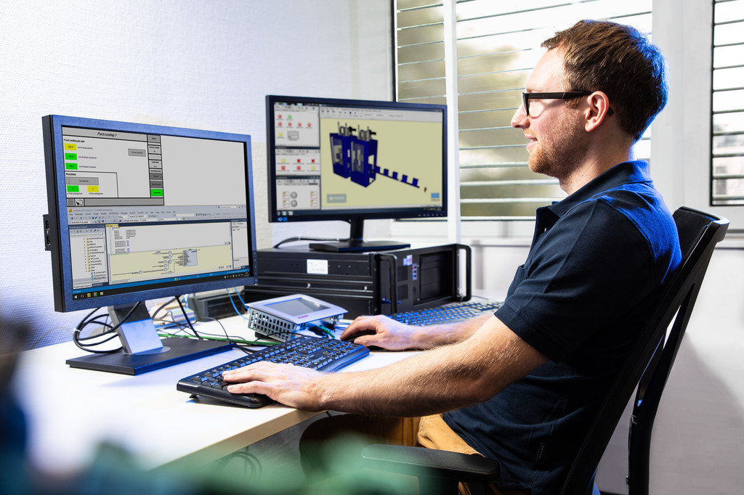  
Seamless commissioning of systems thanks to optimal preparation on the digital twin

**About Kautex Maschinenbau**

Kautex Maschinenbau develops intelligent production solutions for the production of plastic containers. The company has shaped the plastics sector for 85 years with advanced extrusion blow molding machines. It works together with customers and partners to create added value for sustainable, economical production of extrusion blow molding articles of the highest quality.   
A worldwide clientele from a wide range of industrial branches puts its trust in the know-how of a brand which has represented great reliability, durability, and economic benefits for many decades.   
As global market leader, the company employs around 550 people. The main production locations are in Germany and China. With more than 150 people employed in the fields of sales and service on all continents, the company is close to its customers in all locations with a unique service package.

**Contact**

Christian Kirchbaumer  
Head of Marketing Communications

Kautex Maschinenbau GmbH  
Kautexstr. 54  
53229 Bonn

T +49 228 489370  
christian.kirchbaumer@kautex-group.com